**Database Report**

Contents

**Db Report** 2

**Home Task** 2

Query2: 3

Query3: 3

Query4: 4

Query5: 4

Query6: 5

Query7: 5

Query8: 6

Query9: 7

Query 10: 7

Query11: 8

Query12: 9

Query13: 9

Query14: 10

Query15: 10

## **Db Report**

**Home Task**  
Query 1:

Write a query to report orders which were delayed shipped.

--Q1

SELECT TOP (1000)

[OrderID],

[CustomerID],

[EmployeeID],

[OrderDate],

[RequiredDate],

[ShippedDate],

[ShipVia],

[Freight],

[ShipName],

[ShipAddress],

[ShipCity],

[ShipRegion],

[ShipPostalCode],

[ShipCountry]

FROM [Northwind].[dbo].[Orders]

WHERE [ShippedDate] > [RequiredDate];

--***--

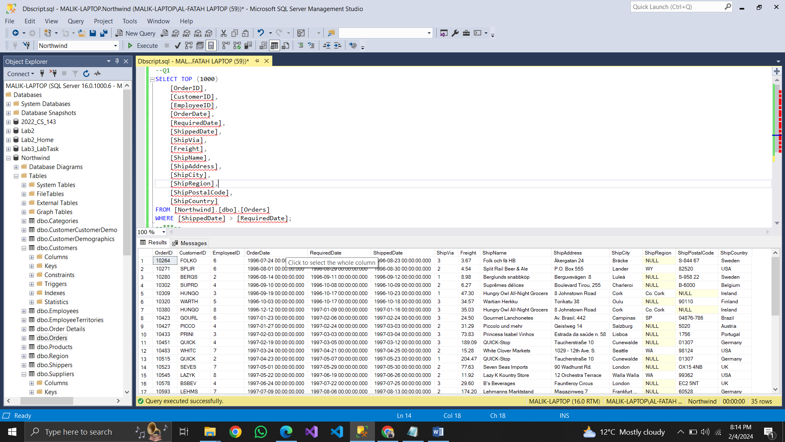

## Query2:

Our employees belong to how many countries. List the name

--Q2

SELECT DISTINCT

[Country],

[LastName],

[FirstName]

FROM [Northwind].[dbo].[Employees];

--***--

--***--

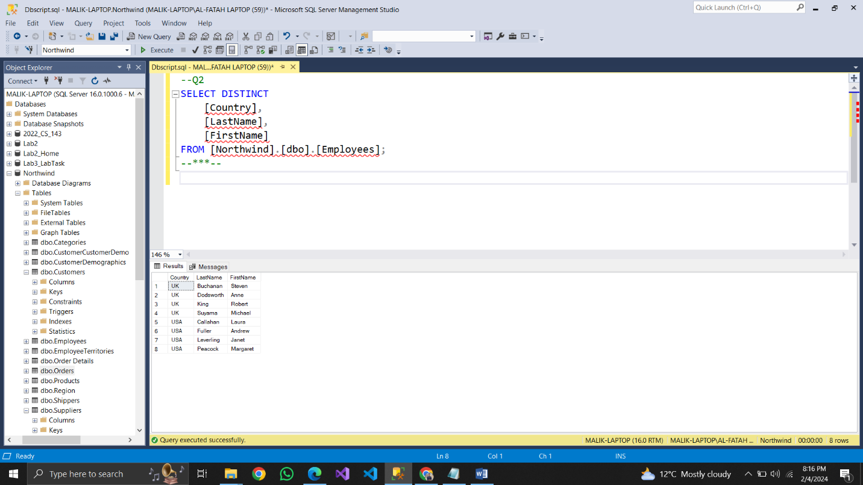

## Query3:

Is there any employee who is not accountable?  
--Q3

SELECT

[EmployeeID],

[LastName],

[FirstName]

FROM

[Northwind].[dbo].[Employees]

WHERE

[ReportsTo] IS NULL;

--***--

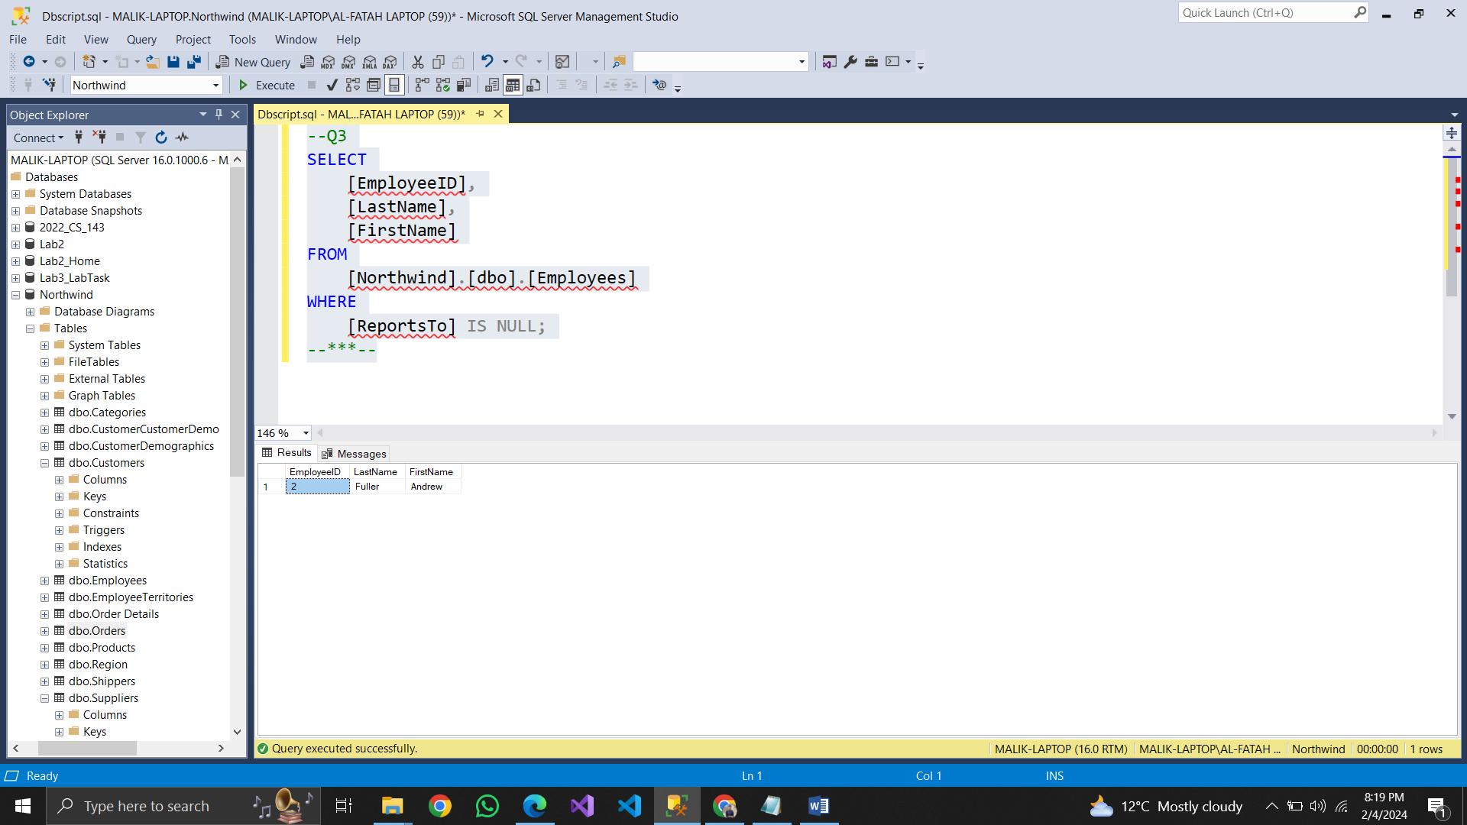

Query4:  
List the names of products which have been discontinued.  
--Q4

SELECT TOP (1000)

[ProductID],

[ProductName]

FROM [Northwind].[dbo].[Products]

WHERE [Discontinued] = 1;

--***--

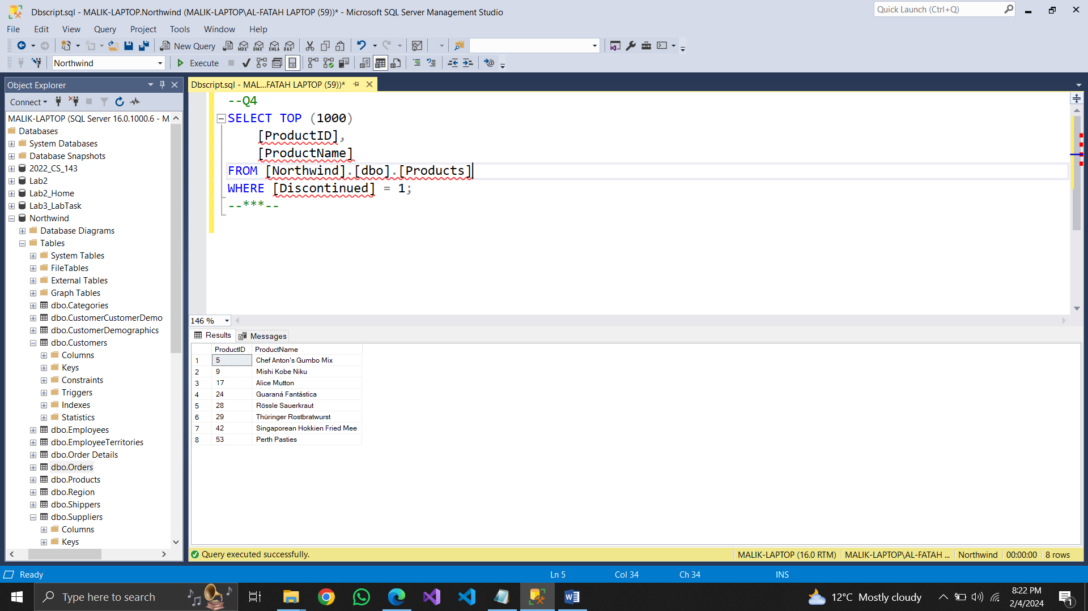

## Query5:

List the IDs the orders on which discount was not provided.  
--Q5

SELECT TOP (1000)

[OrderID],

[ProductID],

[UnitPrice],

[Quantity],

[Discount]

FROM [Northwind].[dbo].[Order Details]

WHERE [Discount] = 0;

--***--

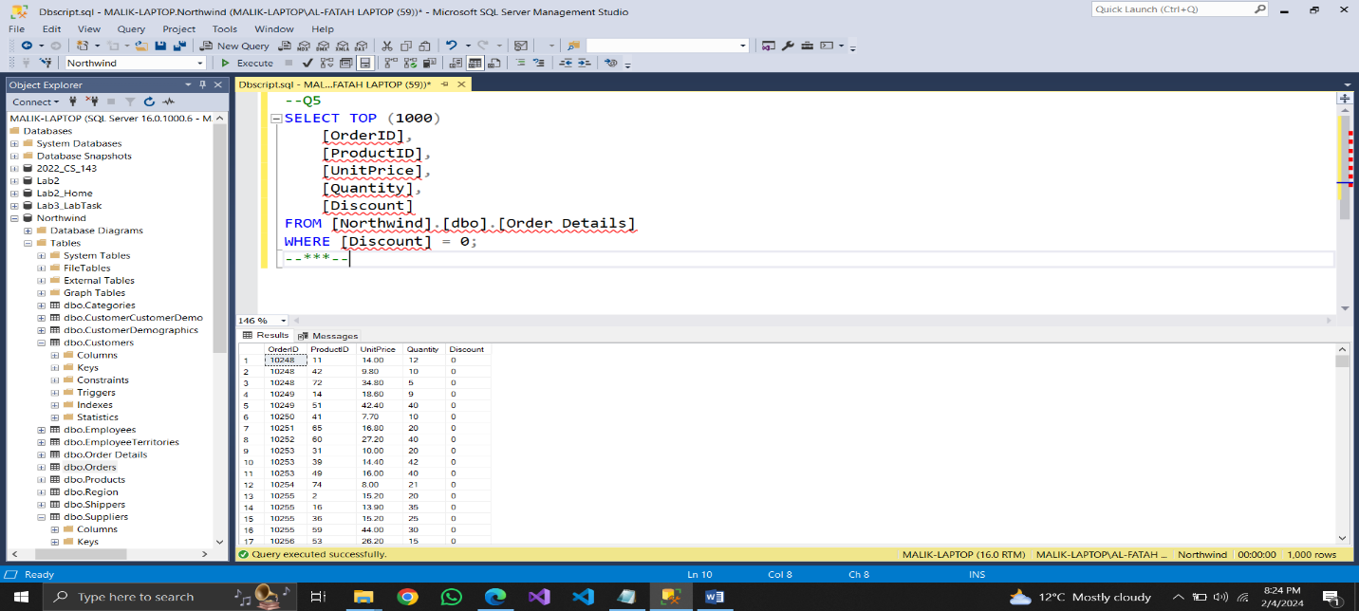

Query6:  
. Enlist the names of customers who have not specified their region.  
--Q6

SELECT TOP (1000)

[CustomerID],

[CompanyName],

[ContactName],

[ContactTitle],

[Address],

[City],

[Region],

[PostalCode],

[Country],

[Phone],

[Fax]

FROM [Northwind].[dbo].[Customers]

WHERE [Region] IS NULL;

--***--

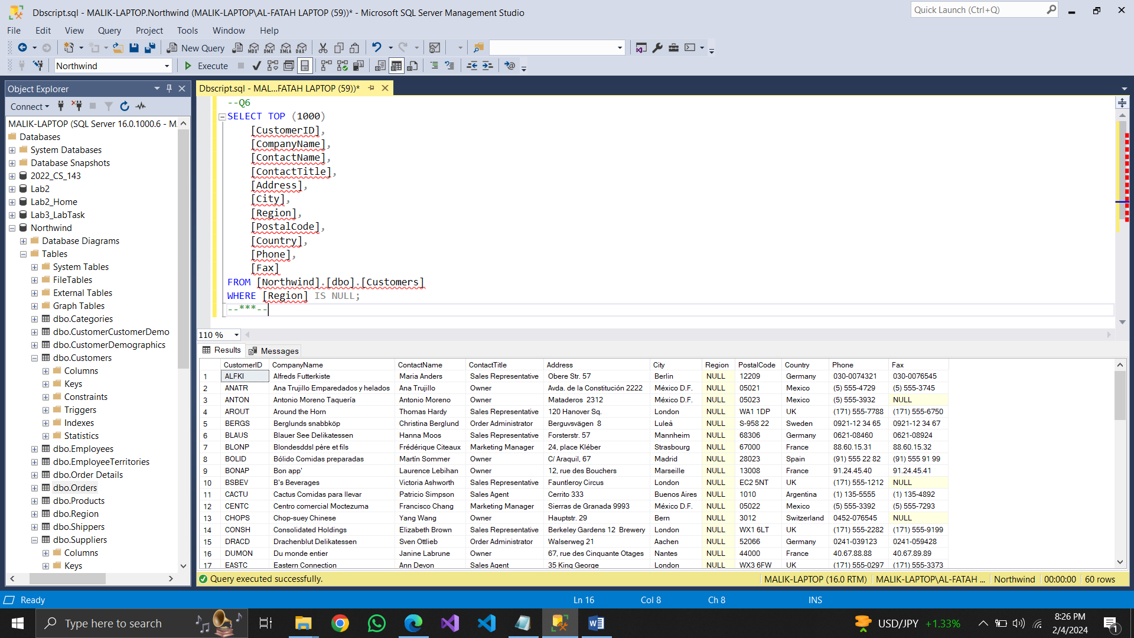

## Query7:

--Q7

SELECT TOP (1000)

[CustomerID],

[CompanyName],

[ContactName],

[ContactTitle],

[Address],

[City],

[Region],

[PostalCode],

[Country],

[Phone],

[Fax]

FROM [Northwind].[dbo].[Customers]

WHERE [Country] IN ('UK', 'US');

--***--

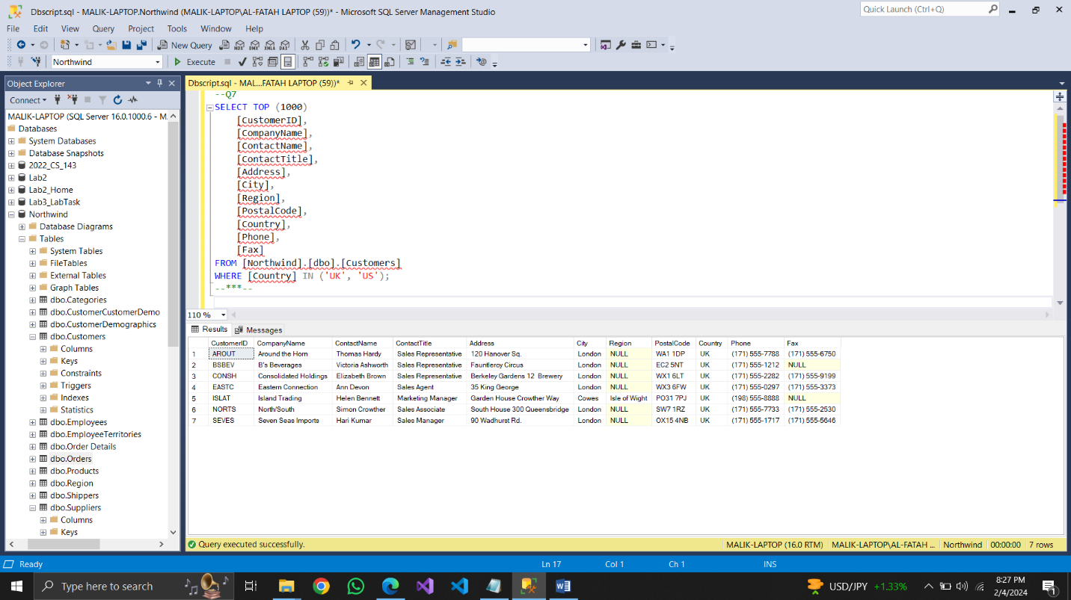

## Query8:

Report the names of companies who have provided their web page

--Q8

SELECT TOP (1000)

[SupplierID],

[CompanyName],

[ContactName],

[ContactTitle],

[Address],

[City],

[Region],

[PostalCode],

[Country],

[Phone],

[Fax],

[HomePage]

FROM [Northwind].[dbo].[Suppliers]

WHERE [HomePage] IS NOT NULL;

--***--

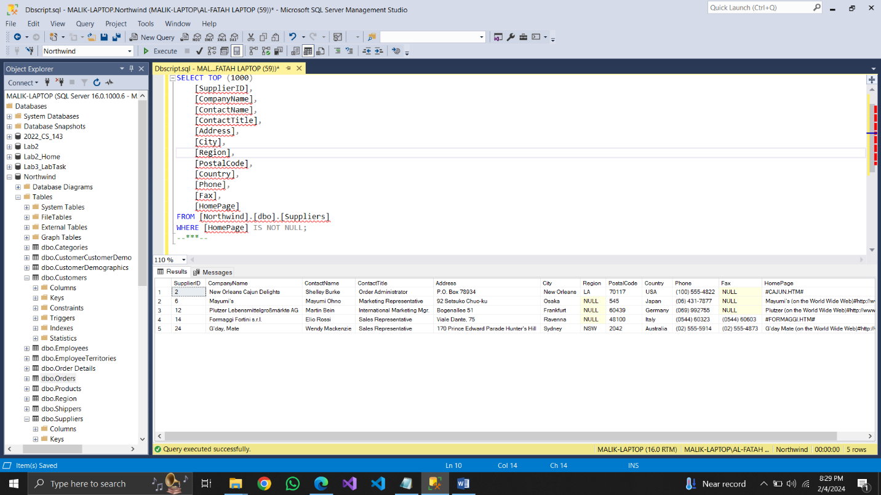

## Query9:

In which countries, products were sold in year 1997  
--Q9

SELECT DISTINCT

O.[ShipCountry]

FROM

[Northwind].[dbo].[Orders] O

JOIN

[Northwind].[dbo].[Order Details] OD ON O.[OrderID] = OD.[OrderID]

WHERE

YEAR(O.[OrderDate]) = 1997;

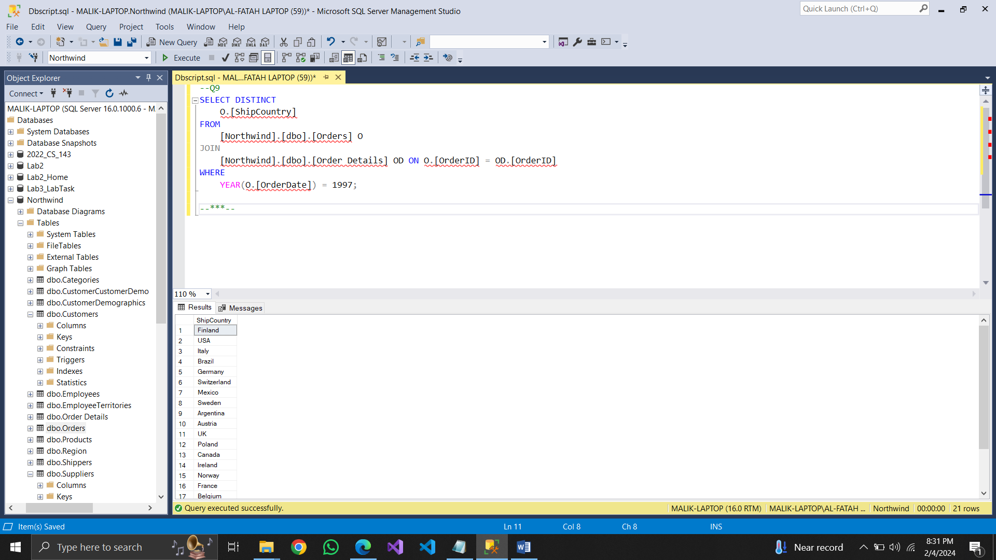--***--

## Query 10:

--Q10

SELECT DISTINCT

[CustomerID]

FROM [Northwind].[dbo].[Orders]

WHERE [ShippedDate] IS NULL;

--***--

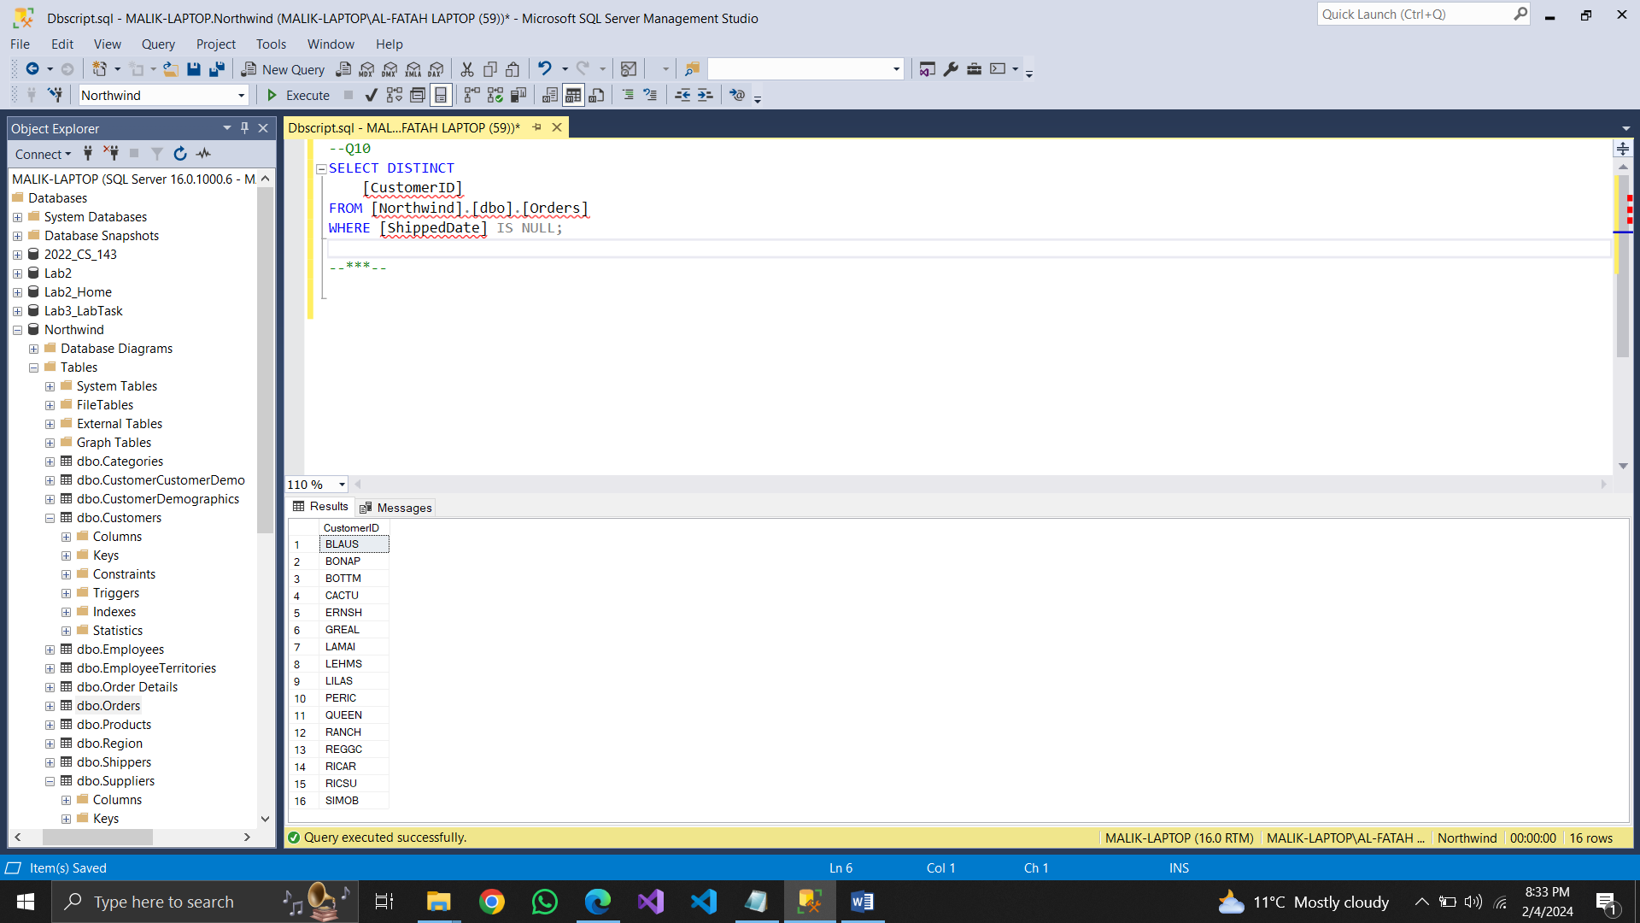

## Query11:

Write a query to report suppliers with their id, company name and city.

--Q11

SELECT TOP (1000)

[SupplierID],

[CompanyName],

[City]

FROM [Northwind].[dbo].[Suppliers];

--***--

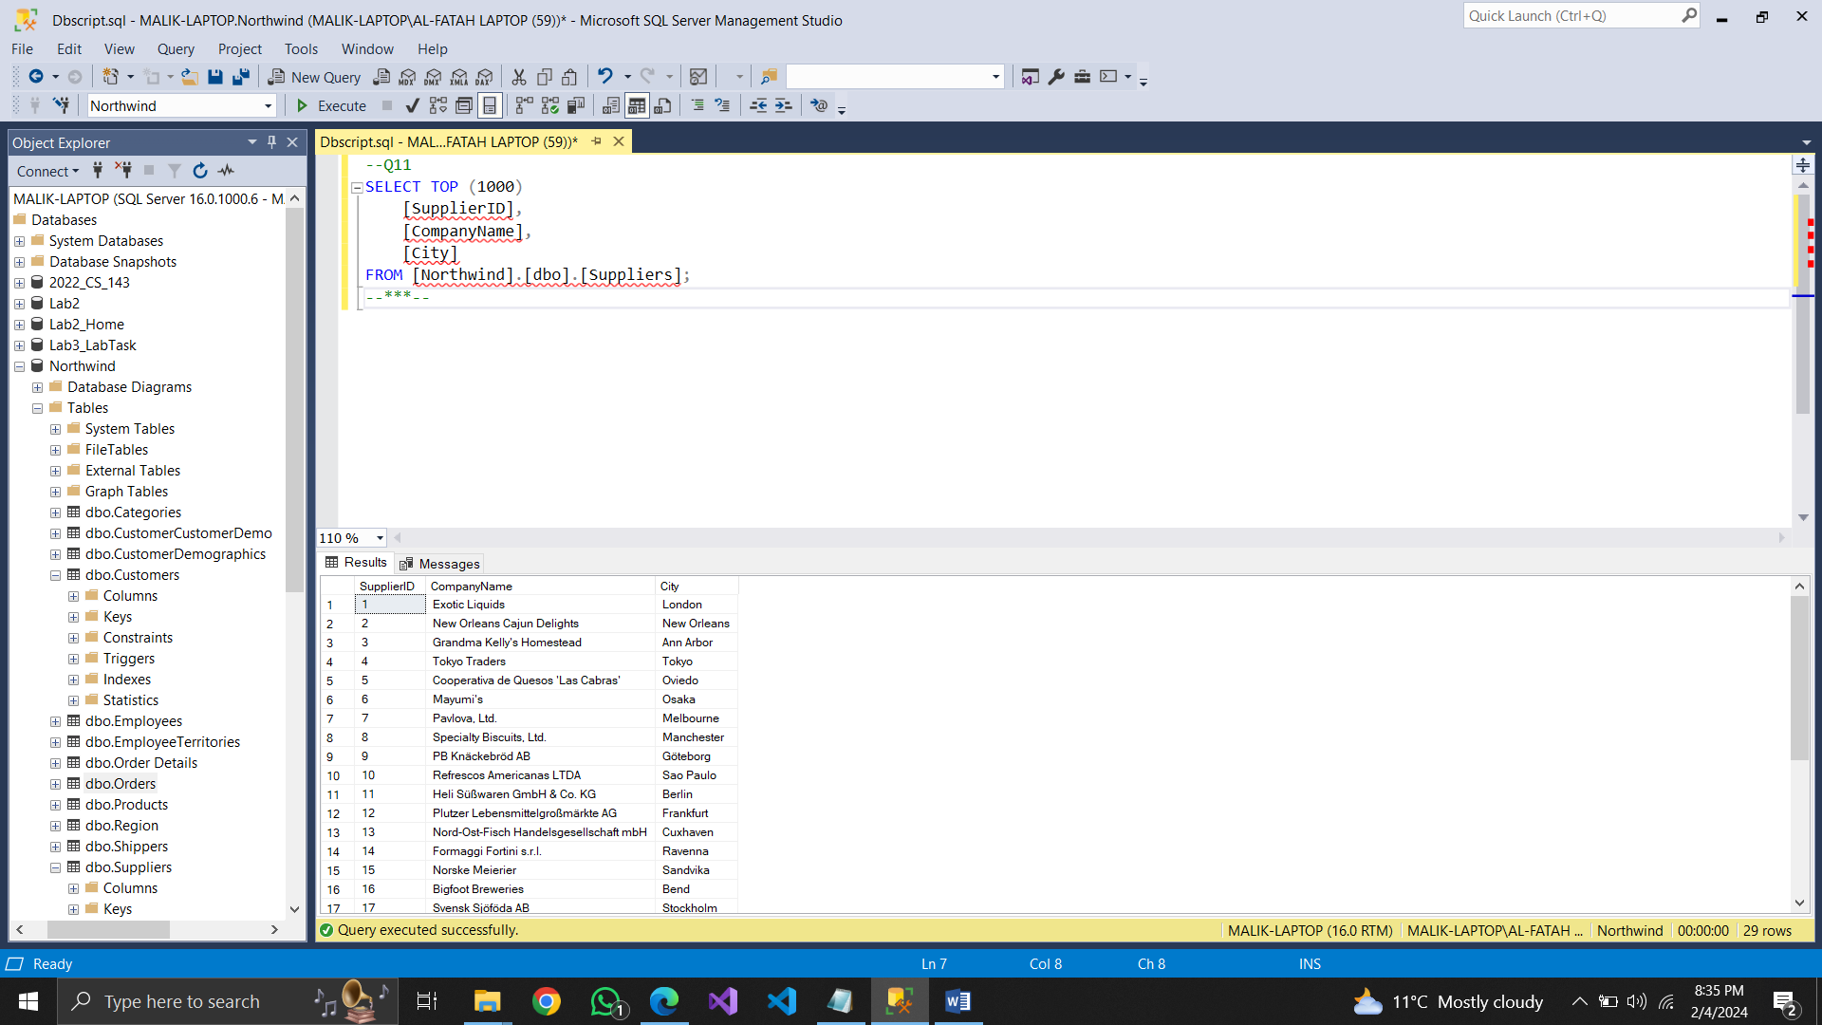

## Query12:

Our employees belong to how many countries. List them who are used to live in London  
--Q12

SELECT DISTINCT

[EmployeeID],

[LastName],

[FirstName],

[City],

[Country]

FROM [Northwind].[dbo].[Employees]

WHERE [City] = 'London';

--***--

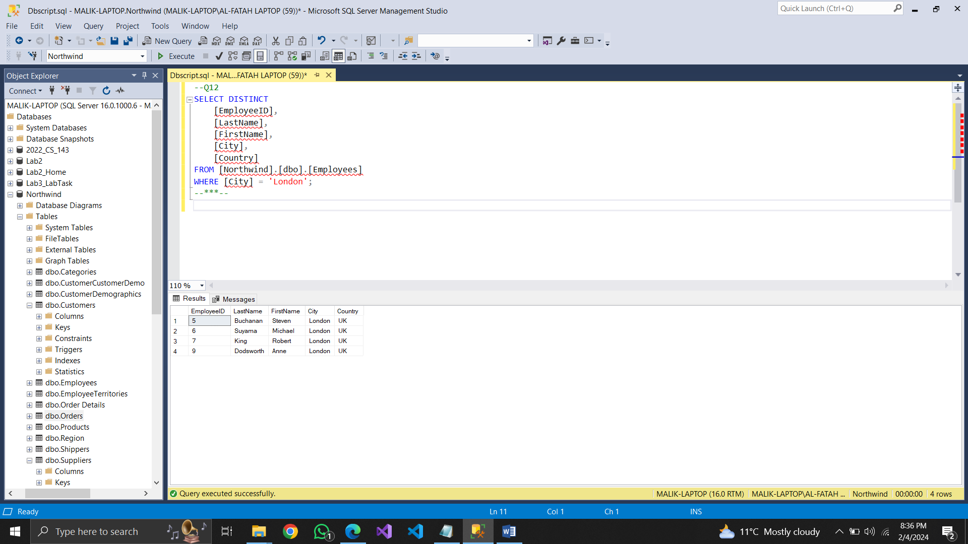

## Query13:

. List the names of products which have not been discontinued.

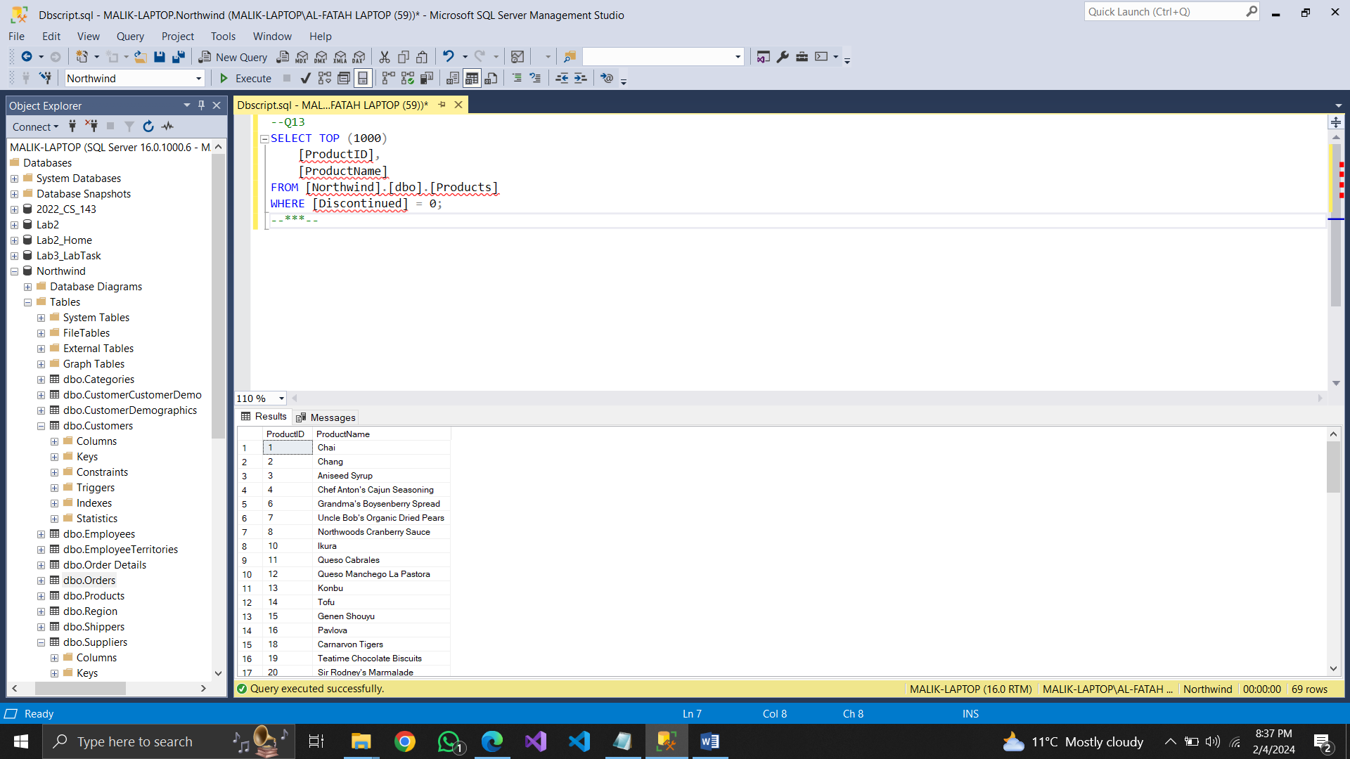

## Query14:

. List the IDs the orders on which discount was 0.1 or less.

--Q14

SELECT TOP (1000)

[OrderID],

[ProductID],

[UnitPrice],

[Quantity],

[Discount]

FROM [Northwind].[dbo].[Order Details]

WHERE [Discount] <= 0.1;

--***--

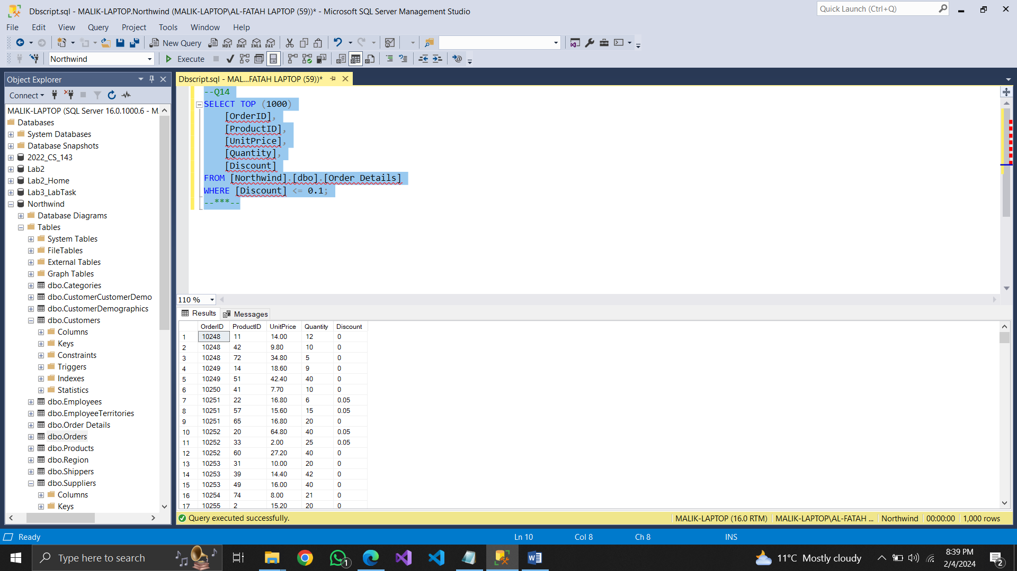

## Query15:

Enlist the IDS, names of employees and their contact number with extensions who have not specified their region.  
--Q15

SELECT TOP (1000)

[EmployeeID],

[LastName],

[FirstName],

[HomePhone],

[Extension]

FROM [Northwind].[dbo].[Employees]

WHERE [Region] IS NULL;

---***---

